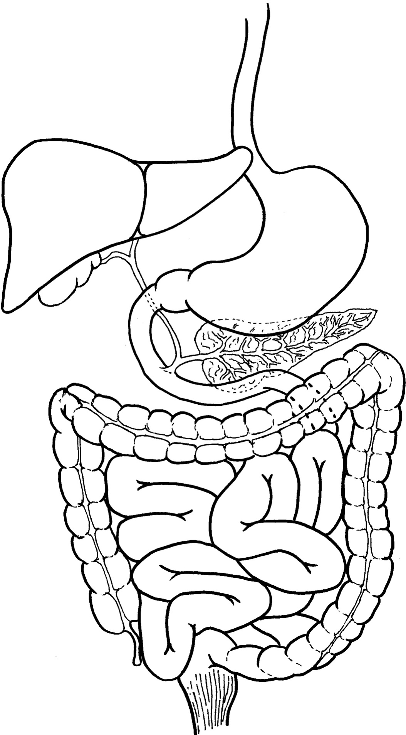

**Large Intestine**

**Summary of the Digestive System**

**Mouth**

Mechanical digestion:

Chemical digestion:

Carbohydrate 🖵 Protein 🖵 Lipids 🖵

Enzymes produced:

Gall Bladder

Teeth

Number and type:

**Small Intestine**

Mechanical digestion:

Chemical digestion:

Carbohydrate 🖵 Protein 🖵 Lipids 🖵 RNA/DNA 🖵

Enzymes produced:

Surface area increased by:

Oesophagus

**Stomach**

Mechanical digestion:

Chemical digestion:

Carbohydrate 🖵 Protein 🖵 Lipids 🖵

Enzymes produced:

**Pancreas**

Enzymes produced:

**Liver**

* Stores glucose as glycogen
* Breaks down excess protein forming urea
* Stores excess glycogen as fat
* Makes bile to aid lipid digestion
* Makes plasma proteins and blood-clotting factors
* Stores vitamins (A and D) and minerals (iron)
* Breaks down toxins and hormones
* Heat production